- In the PLATO planning software, save a plan as “export to RTOG” in the BRACHYTHERAPY module.
A. In the dose preference panel, grid size should be 2 mm for dose matrix.
B. The display type of isodose lines should be absolute dose, not relative dose to prescription.
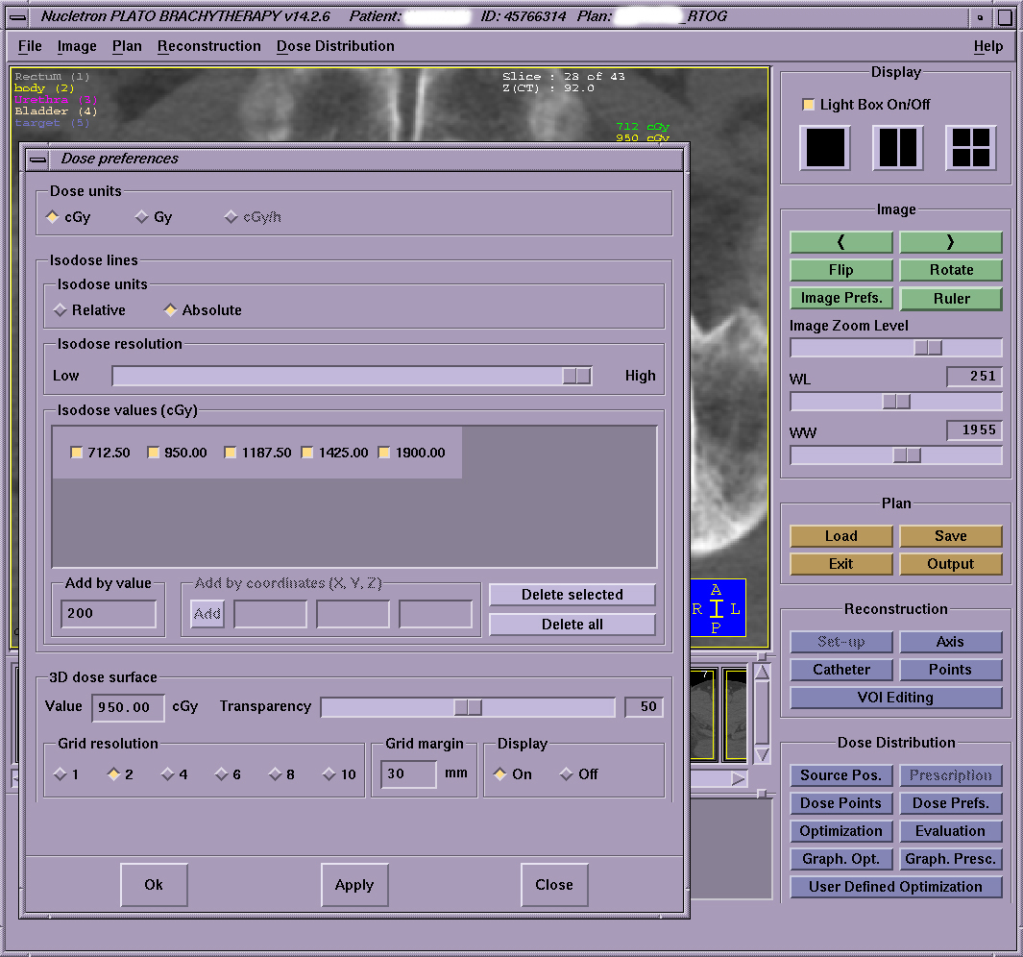

C. Determine the total number of fractions, type of applicator, and name of organ used for applicator

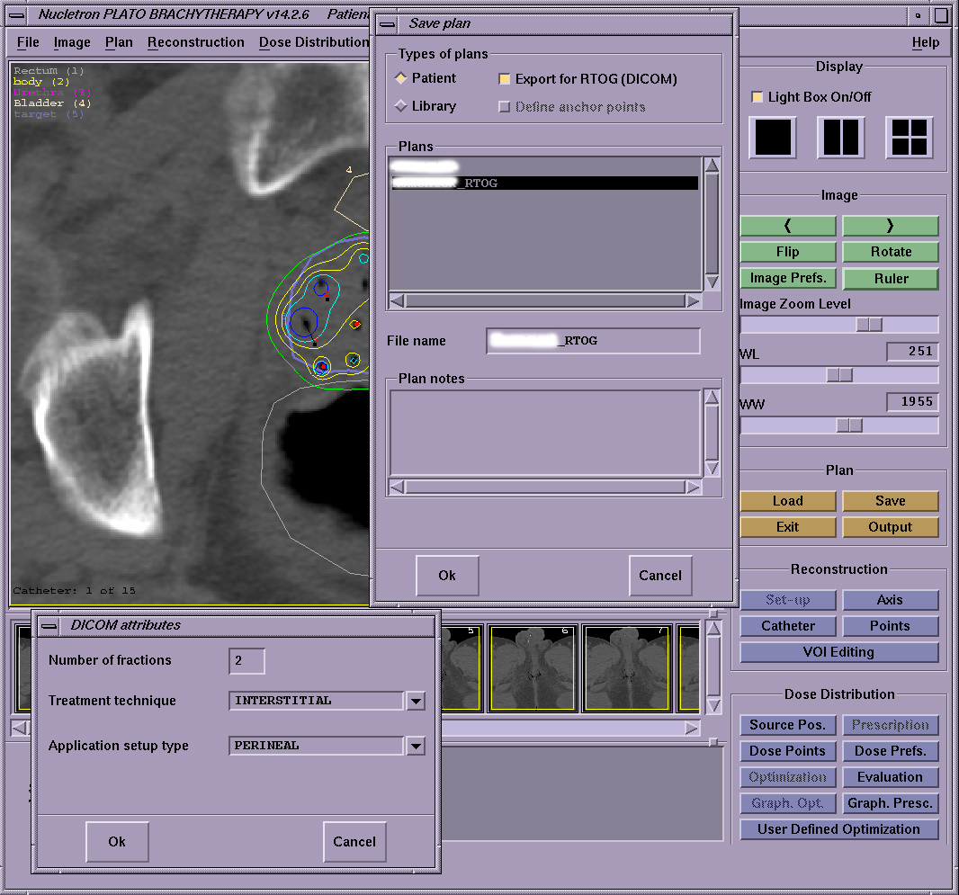

- Exit the RTOG plan as well as brachytherapy module, and then enter into “export” panel in the “File” menu in the Plato Planning System (PPS) window menu for the patient.
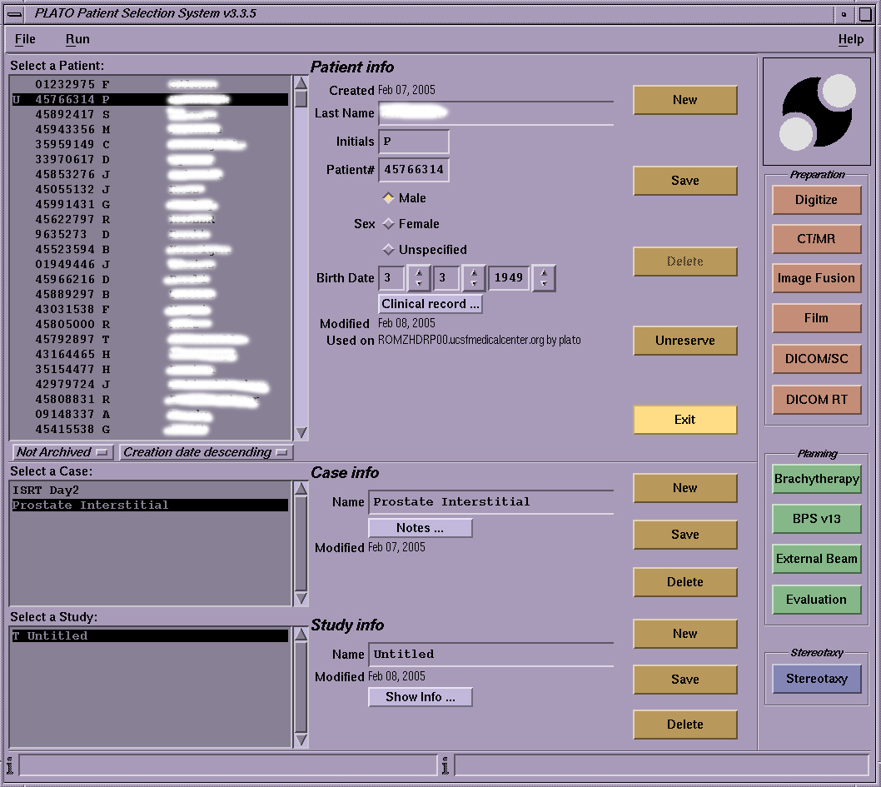

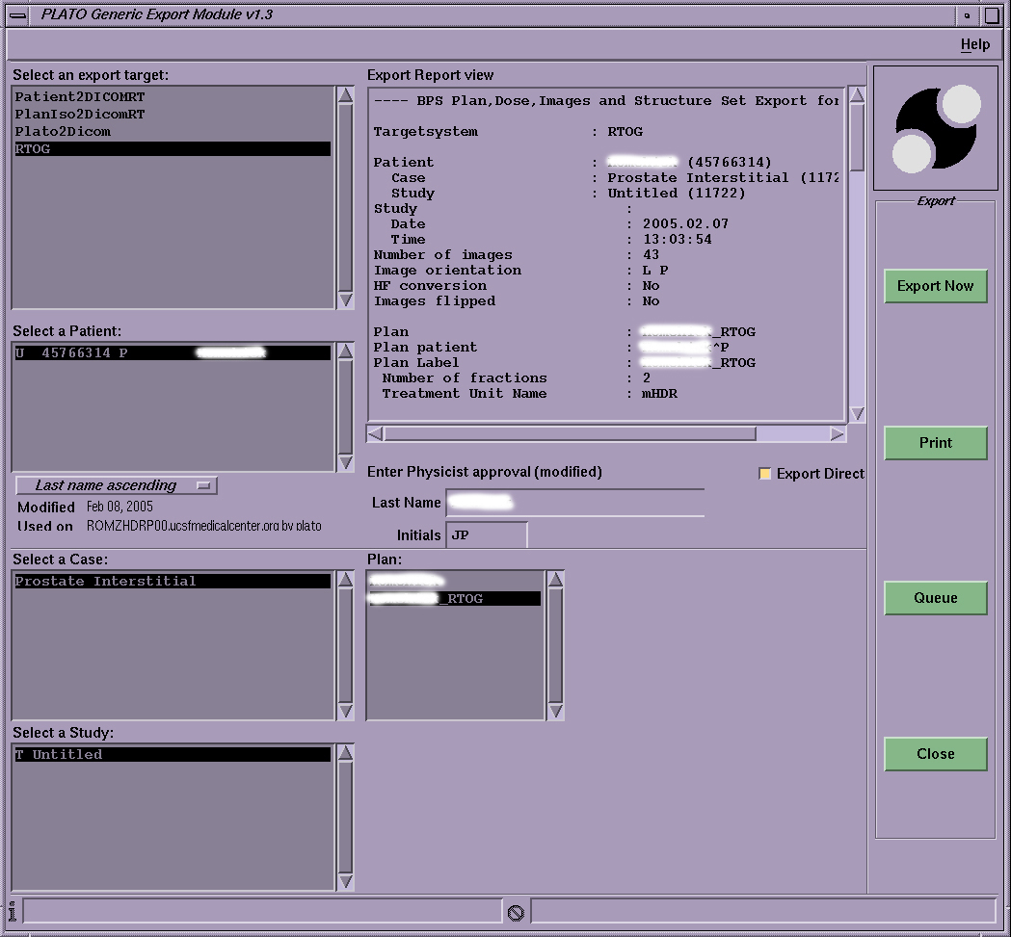

- Before exporting to the PC, logged-in the PC and run the software called “ITC_DICOM” on PC.
Click “Run Dicom Receiver” button on the window of “ITC_DICOM” software. The software is now ready te receive the files from Plato
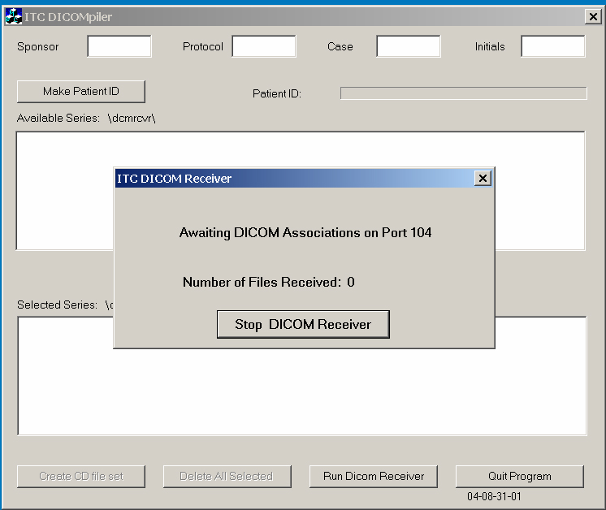

- Export RTOG-plan file into the PC: Click “Export Now” button in export module (second Figure in step 2)
The proper file transfer process from PPS to PC could be confirmed by noting the increase of the number of files received in the window of “ITC_DICOM” software.
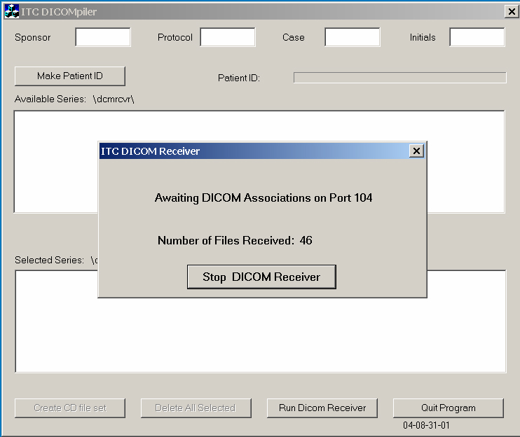

Fill out “Sponsor, Protocol, Case and Initials” and click “make a patient ID” button to make Patient ID.

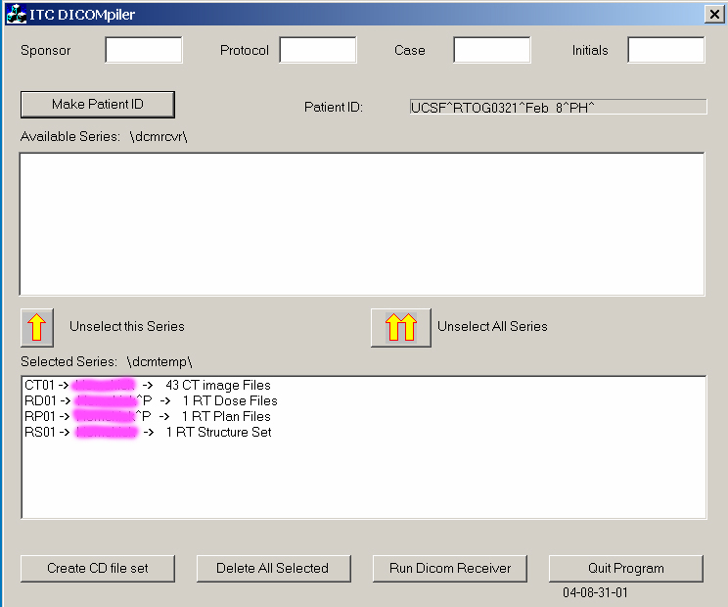

Click the button of “Create CD file set” in ITC_DICOM.

All the exported files from PPS would be saved in the subdirectory of DICOM “\dicom\dcmcd\”. A package of RTOG exported files consists of many Dicom image files (the CT slices), a radiation therapy (RT) plan file (RPxxxx), a RT structural set file (RSxxxx), a RT dose file (RDxxxx). The “dcmcd” folder is created automatically if it does not exist.

Finally, the content of the folder “dcmcd” should be submitted to RTOG0321 protocol headquarter via FTP.
