RPC Spine Phantom

Guidelines for Planning and Irradiating the RPC Spine Phantom.
September 2009

In order to complete the phantom test the following steps need to be completed: (1) request an account to the Advance Technology Consortium (ATC, http://atc.wustl.edu), (2) completion of the phantom treatment experiment and (3) submission of the treatment plan designed for the phantom electronically to the ATC. The purpose of this test is to confirm that the dose distribution planned by each institution can be delivered by that institution, and treatment plans can be correctly submitted to the ATC.
The RTOG is requesting that each institution keep the phantom for no more than 2 week. During this two-week period, the institution will image, plan, and irradiate the phantom and return it to the Radiological Physics Center (RPC). Thank you for your cooperation with this constraint.
This phantom has been designed and constructed by the RPC. The RPC phantom contains two imaging and dosimetric inserts. The insert, called spine, contains a PTV. There are two orthogonal sheets of radiochromic film passing through the center of the target and four TLD capsules within the target. The insert also contains normal structures: the spinal cord, bone and the esophagus. The insert which is part of the left lung contains a centrally located CTV. DO NOT treat this target. The phantom also contains normal structures: left and right lung and the heart with one TLD capsule in its center.

If you have any questions, please contact the appropriate person.
If you have any questions, please contact the appropriate person.
RPC Nadia Hernandez (713)-745-8989 Nhernand@mdanderson.org
RPC Andrea Molineu (713) 745-8989 amolineu@mdanderson.org
ITC Bill Straube (314) 362-9762 itc@castor.wustl.edu

DOSIMETRY INFORMATION TO BE SUBMITTED:

The following information is to be submitted to the RPC (include in the phantom shipping box):

- Original hard-copy of the plan and isodose distributions applying correction for tissue heterogeneity in the sagittal and axial planes through the center of the target volume. Please ensure that each plane fills an entire page and that a scale is printed on the page.
- A completed RPC Spine Phantom Institution Information form.

The following information is required to be submitted to the ATC (see protocol for additional submissions) (results will not be analyzed until the digital treatment plan is received):

- The digital treatment planning data in the RTOG Data Exchange or DICOM format using either FTP or tape (see the ITC web site for details).
Please cc the RPC (rpc@mdanderson.org) when you inform the ATC of the electronic submission. This will allow us to keep better track of who has and has not submitted the benchmark electronically.
- Original hard copy isodose distributions applying correction for tissue heterogeneity in the sagittal and axial planes through the target center (identical to those sent to the RPC)
- A copy of the completed RPC Spine Phantom-Institution Information form that was sent to the RPC
- Send the hard copy data (isodoses and forms) to:
Bill Straube, M.S.
Image Guided Therapy Center
Washington University
4511 Forest Park Ave, Suite 200
St Louis, MO 63108

DOSE PRESCRIPTION:
1. USE tissue heterogeneity correction when planning and calculating M.U. for the phantom irradiation.
2. Only photon beams with nominal accelerating potential between 4 and 15 MV are allowed.
3. The plan designed for this phantom requires stereotactic localization and IMRT techniques or any other dose painting techniques. The uncertainty in localization should be less than 2 mm from simulation/planning to the end of treatment delivery.
4. Three-dimensional coplanar or non-coplanar beam arrangements using IMRT should be designed to deliver highly conformal prescription dose distributions. The beam arrangement should be mostly from the posterior direction to avoid passing the radiation beam through the lungs. Intensity-modulated arc therapy with either multiple static cones or dynamic conformal MLC can be used. For arc rotational techniques, every effort should be used to limit the radiation through the lung.

The prescribed dose to the phantom is 6 Gy to at least 90% of the PTV. The prescription dose will be delivered to the margin of the target volume It should be delivered in 1 fraction with the following constraints:
- PTV:
  - Prescribed dose of 6 Gy to at least 90% of the PTV.
  - The minimum dose to the target should be no less than 5.25 Gy
  - Any dose greater than 105% of the prescription dose should not occur outside of the target volume.

- Critical Normal Structures (spinal cord, heart, esophagus, skin and lungs):

  - Constraints for all the normal structures are specified in the following table:

Normal structure | Volume | Volume Max (Gy) | Max Point Dose (Gy)
Spinal Cord | <0.35cc  <1.2cc | 3.75  2.63 | 5.25
Heart | <15cc | 6 | 8.25
Esophagus | <5cc | 4.46 | 6
Skin | <10cc | 8.63 | 9.75
Whole Lung  (Right & Left) | 1000cc | 2.78

It is important to follow the constraints applied to normal structure as listed above.

If your plan does not conform to the above prescription, you may not be credentialed and will have to irradiate the phantom again.

Please, DO NOT TREAT the CTV located in the left lung

IRRADIATING THE PHANTOM
- Material included in box:
The phantom should be imaged, planned and irradiated as if it were an actual protocol patient, incorporating all of your customary quality assurance checks.
Spine Phantom, with 3 TLD capsules taped to the shell (1 on left side, 1 on right side and 1 on anterior side)
Insert for the left lung
Insert for the spine
Rubber hose
Acrylic cylinder containing TLD in one of the ends
Envelope with background film and TLD (hidden from your view; please don’t try to find it)
Mailing label to return case to RPC at the RPC’s expense.
Traditional RPC TLD block and irradiation table. (Please irradiate this at the time you irradiate the phantom.)
Procedures:
- Fill the phantom with water:
  - Thread the rubber hose into the filler hole placed on the base of the phantom.
  - Fill slowly with water (the rubber hose stretches over most faucets). There is a breathing hole on the phantom, make sure it is open, to allow the pressure to release. You may need to jiggle the phantom to release air trapped inside the cavity.
  - Remove hose and replace acrylic screw.
- Allow the phantom to sit with water in it for 20 min. to check for leaks.
- Look in the insert spaces (lung and spine) and check for water leakage. If you find any water call the RPC. If not, proceed to the next step.
- Position the spine insert. Remove the screws located on the left and right side of the insert place. Align the red mark. When it is in the correct position put the screw back.
- Position the lung insert. Align the red mark. Make sure that the insert is in its correct position by making small rotations of the insert around its central axis. When it is in the correct position it will be locked in place by an indentation at the end of the insert.
- Position the acrylic cylinder labeled “heart cylinder” in the hole labeled “heart” in the superior part of the phantom. The hole and the cylinder are marked in green. You will see a TLD capsule in the cavity closed with a screw. The end with the TLD should be inserted first.
- Position and CT the phantom as you would a patient including immobilization techniques. You may wish to scan with 1.5 mm slices especially near the target to better identify the TLD capsules. NOTE: There are TLD on the external shell of the phantom to give us an estimate of the CT dose to the target.
- Remove inserts from the phantom during planning process. Store inserts in a dry place. Store inserts and phantom where they will not be irradiate.
- Segment the phantom images contouring the skin, lungs, heart, spinal cord esophagus, bone and PTV. Also contour all the 5 TLD volumes. Please use the following names for these contours:
PTV_TLD_sup_ant for the superior anterior TLD in the
target,
PTV_TLD_inf_ant for the inferior anterior TLD in the
target,
PTV_TLD_sup_post for the superior posterior TLD in the
target,
PTV_TLD_inf_post for the inferior posterior TLD in the
target,
HEART_TLD for TLD in the heart
• The dimensions of the TLD volume are approximately 10 mm long by 2 mm diameter
• The outside dimensions of the TLD capsules are 15 mm long by 4 mm diameter; the TLD axis is normal to the axial plane. (The capsules and the TLD should be visible on CT image)
- Plan the treatment as specified in the DOSE PRESCRIPTION above.
- Look in the insert spaces and check for water leakage. If you find any water call the RPC. If not, follow the instructions in step 5 and 6 to position the inserts again and proceed to the next step.
- Perform your customary QA of the plan prior to irradiating the phantom.
- Irradiate the RPC TLD block according to the instructions provided.
- Position the phantom as you would a protocol patient including immobilization techniques. Try to avoid positioning the axial film at the abutment of adjacent MLC leaves or adjacent arcs. Abutting fields or leaves on the film may increase the uncertainty of the measurement.
- REMOVE THE TLD CAPSULES LOCATED ON THE EXTERNAL SHELL. Put them into the designated envelope.
- Irradiate the phantom with the developed plan.
- Remove the acrylic cylinder from hole and place it in the box.
- Remove the inserts and place them in the box.
- Please verify that there is no water in the inserts space. If you find any water call the RPC.
- Remove the screw on the base of the phantom and drain the water from the phantom.
- Put the empty phantom in the box.
- Make sure that the envelope with the TLD on the shell and the rubber hose are in the box.
- Include the dosimetry data discussed above. Complete the attached forms. Be sure to include the scale used on the images coming from your TPS.
- Return the complete package to the RPC.

RPC Spine Phantom Institution Information
(Original to RPC, copy to ITC)
Please email the RPC , at rpc@mdanderson.org. to let us know when you are going to irradiate the phantom. Please include on the subject: irradiation of spine phantom.
Institution:
Address:

Person performing irradiation:
Person to receive report:
Oncologist to receive report:
Person to call in case of questions:
Phone Number: Fax Number:
Email address: _________________________________________________________________

Treatment Unit:
Manufacturer: Model:
In-house specification:
Photon Beam: Nom. accelerating potential:______(MV) IR (TMR 20/TMR 10): ___ %dd(10)_{x ______}

Intensity Modulation Device:
___ MIMIC ___ Multileaf Collimator ___ Solid Attenuator Modulation

IMRT Technique:
___ Segmental (step and shoot) MLC ___ Dynamic MLC ___ Tomotherapy
___ VMAT ___ Rapid Arc Other: _________________________________
Stereotactic System used for localization: _________________________________________
Manufacter:____________________________Model:____________________________
Other: _____________________________________________________________________
Treatment Planning System:

Manufacturer: ______________________ Model: ________________ Algorithm__________
Software: ____________________________ Version Number:________________________
Treatment of Phantom:
Date of Irradiation:

Dose specified is to:  Muscle  Water
Indicate the dose delivered to the TLD as determined by your treatment planning computer
TLD | Mean Dose (Gy)
PTV_TLD_sup ant
PTV_TLD_inf ant
PTV_TLD_sup post
PTV_TLD_inf post
HEART_TLD
Results of the QA:______________________________________________________________
Did you adjust the MU based on these results?_______________If so, how much?___________
Attach copies of the treatment plan including slices in the sagittal, axial and coronal film planes.
Comments:
Please enclose original copies of your treatment plans. Include axial and sagittal planes through the target center. Include scaling factors for each plane. FTP the digital treatment planning data.

For Office Use Only | TLD Batch | Film Batch | Phantom ID # | Code | Date Sent |  | Date Rec'd

This is a cross sectional view of the phantom
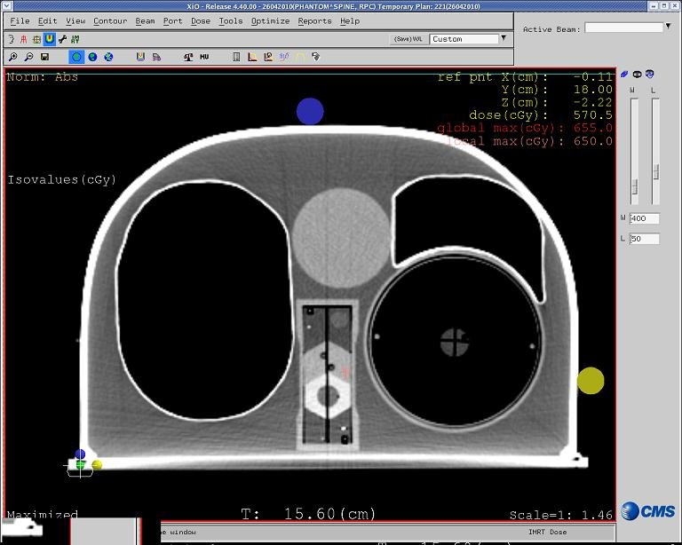
Right
Lung
Left
Lung
Heart

Sagittal Film Plane
Esophagus
Anterior
Left
Right
Posterior

Axial Film Plane
Bone
Cord
PTV

Note: Please ignore all markings on the external shell of the phantom, use your own system to position the phantom.

Note: You need to deliver 6.0 Gy to the PTV located on the Spine insert in 1 fraction.
Total dose to the PTV 6.0 Gy
DO NOT treat the target located inside the left lung

Thanks

Phantom team @ RPC

